Korea-Vietnam Peace Village Project (KVPVP)
Annual Report
January – December 2024

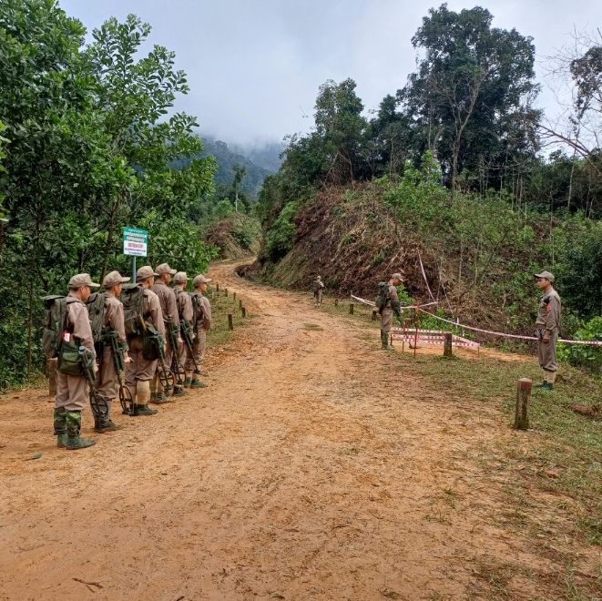 | 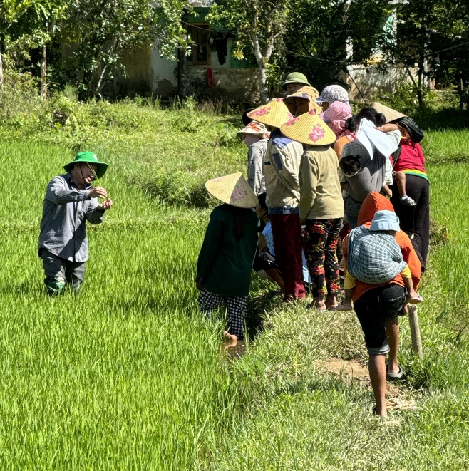

January 2025

ACRONYMS
APMBC | Anti-Personnel Landmine Ban Convention
ARMAC | ASEAN Regional Mine Action Centre
ARR | Assistant Resident Representative (UNDP)
ASEAN | Association of Southeast Asian Nations
CHS | Commune Health Station
CMAA | Cambodia Mine Action and Victim Assistance Authority
CRH | Climate-Resilient House
DARD | Ministry of Agriculture and Rural Development
DOET | Department of Education and Training
DSA | Department of Social Assistance
EO | Explosive Ordnance
EORE | Explosive Ordnance Risk Education
ESMP | Environmental and Social Management Plan
FFS | Farmer Field School
GICHD | Geneva International Centre for Humanitarian Demining
IM | Information Management
IMAS | International Mine Action Standards
ISU | Implementation Support Unit
JPCC | Joint Project Coordination Committee
JPMU | Joint Project Management Unit
KOICA | Korea International Cooperation Agency
KPI | Key Performance Indicator
KVMAP | Korea-Vietnam Mine Action Project
KVPVP | Korea-Vietnam Peace Village Project
M&E | Monitoring and Evaluation
MAG | Mines Advisory Group
MAPG | Mine Action Partnership Group
MAWG | Mine Action Working Group
MoD | Ministry of Defence
MOLISA | Ministry of Labor, Invalids, and Social Affairs
MPI | Ministry of Planning and Investment
NDM-UN27 | 27th International Meeting of National Mine Action Programme Directors and United Nations Advisers
NPA | Norwegian People's Aid
PMU | Project Management Units
PPMU | Provincial Project Management Unit
PSC | Provincial Site Command
PWD | Persons with Disabilities
QA | Quality Assurance
QC | Quality Control
QM | Quality Management
QTMAC | Quang Tri Mine Action Centre
ROK | Republic of Korea
RR | Resident Representative (UNDP)
S&C | Survey and Clearance
SCU | Site Command Unit
SDGs | Sustainable Development Goals
SES | Social and Environmental Standards
SESP | Social and Environmental Screening Procedure
TS/CL | Technical Survey and Clearance
UNDP | United Nations Development Programme
UXO | Unexploded Ordnance
VA | Victim Assistance
VietGAP | Viet Nam’s Good Agricultural Practices
VNMAC | Viet Nam National Mine Action Centre

TABLE OF CONTENS

1. PROJECT SUMMARY 5
2. PERFORMANCE REVIEW 7
2.1. Monitoring and Evaluation Activities 7
2.2. Overall Project Result 11
2.3. Performance during the Target Period 13
2.3.1. Project Preparation Milestones 13
2.3.2. Outcome 1. Mine Action and Human Security 13
2.3.3. Outcome 2. Sustainable Rural Development 20
2.3.4. National and International Coordination 23
2.3.5. Operations 25
2.3.6. Challenges and Counterplans 30
2.4. Achievement(s) in Cross-Cutting Issues 33
2.4.1. Gender mainstreaming 33
2.4.2. Social and Environment Management 33
2.5. Communication and Partnership with KOICA 34
2.6. Risk Management 36
2.7. Financial Management 37
3. ANNUAL WORK PLAN FOR YEAR 2025 38
4. ANNEX 40

PROJECT SUMMARY
Project Title | Korea-Vietnam Peace Village Project (KVPVP)
Organization | United Nations Development Programme (UNDP) Viet Nam  - Ms. Sabina Stein, Assistant Resident Representative (ARR), Head of Governance and Participation Team (GPT); sabina.stein@undp.org  - Ms. Nguyen Thu Ha, KVPVP Project Manager; nguyen.thu.ha1@undp.org
Date of Submission | January 2025
Target Country | Viet Nam
Project Location | Thua Thien – Hue, Quang Ngai and Binh Dinh
Beneficiaries | Direct: The project directly benefits 1,103,011 individuals, including at least 388,083 net direct beneficiaries. These include women, men, girls and boys in target provinces whose lives and limbs are protected by using land that has been cleared or where hazards have been reduced for productive, frequent, or sustainable activities. Other direct beneficiaries include household members trained in explosive ordnance risk education (EORE), survivors receiving victim assistance (VA), and poor households supported through the project.  Indirect: Indirect beneficiaries include members of the same communities as direct beneficiaries, even if they do not use the cleared land themselves; individuals who learn from those reached by EORE; and household members of VA recipients. Additionally, if models and approaches developed through this project are replicated in other parts of Vietnam, a significantly larger population across the country may indirectly benefit from the project’s interventions.
Project Period | January 2022 – December 2026 (60 months)  (Actual start date: 2 January 2023) *Project implementation delay
Goal and Objectives | Objectives:  1) To survey and clear land for the socio-economic development of local communities.  2) To support socio-economic development for local communities living on and around newly cleared land.  3) To strengthen the resilience of local communities, especially unexploded ordinance (UXO) survivors, to mines, disasters, and other risks.  Outcome 1: Improved human security for communities in target areas  Output 1.1: Mine action authorities strengthened capacity to meet current requirements and address residual contamination.  Output 1.2: Contribute into addressing post-war landmines/EO contamination in 3 provinces in the prioritized areas for the development of peace villages.  Output 1.3: Effective investment, implementation and enforcement of the regulations related to support for survivors and persons with disabilities (PWDs) in target areas.  Outcome 2: Enhanced sustainable rural development through increased resilience of livelihoods and infrastructure of target communities  Output 2.1: Climate-smart and resilient agriculture for people in target areas  Output 2.2: Increased resilience for people in target areas by providing resilient economic and social infrastructure through flood and storm resilient houses and commune health stations
Project Budget | Total Cost: 23,512,500 USD funded by Korea International Cooperation Agency (KOICA)  (2022: 213,336 USD, 2023: 784,984 USD, 2024: 8,512,192 USD, 2025: 8,077,136 USD, 2026: 5,924,852 USD)  Other Sources: 0 USD
Plan for Monitoring and Evaluation | KVPVP’s Key Challenges and Actions taken in 2024:  1)Capacity Assessment: UNDP and Norwegian People’s Aid (NPA) have developed separate capacity assessment tools for VNMAC, leading to potential overlaps and inefficiencies. This will be addressed and resolved through coordination efforts in 2025.  2)EORE Activities: The appointment of a new EORE manager at Viet Nam National Mine Action Centre (VNMAC) caused delays to EORE project activities; UNDP supported and ensured activity continuity.  3)PDWs and EO Victims Data Management: Technical issues with Department of Social Assistance (DSA)’s software and restructuring hindered PWD/EO victims data collection; UNDP introduction of an interim paper-based questionnaire methods used helped avoid major delays  4)ODA Compliance: DSA’s inability to establish a project management unit delayed implementation. UNDP developed detailed plans with DSA and included VNMAC to streamline operations.  5)Financial Issues: VNMAC faced compliance challenges; UNDP closely monitored and provided guidance.  6)Project Coordination: Lack of coordination between VNMAC and Provincial Project Management Units (PPMUs) for logical sequencing of mine action and rural development activities. UNDP organized and facilitated coordination meetings and introduced coordination guidelines to strengthen the linkages.  7)Timeline Reduction: Delay in Ministry of Defence (MoD)’s approval shortened project timeline creating challenges in complying with Korea’s ODA budget ceiling policies; No-cost extension till end of 2027 was proposed by KOICA.  8)Budget Impacts: Increased deminers’ allowances affected budgets; VNMAC proposed funding increase or explosive ordinance (EO) technical survey and clearance (TS/CL) scope reduction.  9)Procurement Delays: The new Procurement Law (2023) delayed procurement within the agricultural development component. UNDP supported partners with compliance and revised plans.  10)Public Investment Delays: Strict government regulations delayed sub-projects, particularly health station construction. UNDP worked closely with PPMUs to expedite progress.
Changes of Plan | 1) Delays in Mine Action Project Approval: The Vietnamese government took two years to finalize the mine action component of the project after the Minutes of Discussion were signed, compressing the project timeline from five years (2022–2026) to three years (2024–2026). This also requires the five-year budget to be utilized within the shortened timeframe, creating challenges in complying with Korea’s ODA budget ceiling policies.  2) No-Cost Extension: To address these challenges, KOICA requested VNMAC to seek approval from national authorities for a one-year project extension until the end of 2027. This extension would align with the original project design, reduce implementation pressures, and ensure high-quality project outcomes.

PERFORMANCE REVIEW

Monitoring and Evaluation Activities
Monitoring and Evaluation (M&E) activities play a crucial role in ensuring the effective implementation of the approved work plan, adherence to timelines, and maintenance of high-quality standards. These activities are carried out regularly with the active involvement of KVPVP project staff, supported by detailed activity reports from national partners. They also include regular Joint Project Management Unit (JPMU) and Joint Project Coordination Committee (JPCC) meetings, ad-hoc stakeholder coordination sessions, as well as joint field visits conducted by UNDP, KOICA, and VNMAC. Additionally, UNDP submits monthly, quarterly, bi-annual, and annual progress reports to KOICA, providing updates on achievements and addressing any challenges encountered.

Key M&E activities in 2024:
Joint Field Inspection Visits
Two joint quality management (QM) inspections were conducted in 2024. The first, from September 16 to 20, covered Hue, Quang Ngai, and Binh Dinh, and had participants from VNMAC, Provincial Site Command (PSC), KOICA, and UNDP. The second, from December 16 to 20, focused on Hue and Quang Ngai and had participants from VNMAC, PSC, and UNDP. Both visits assessed compliance with operational standards and regulations.
Observations from the field visits show that demining teams generally adhered to the rules and regulations of QM, and that the VNMAC internal QM system at field functions properly. However, the inspectors of VNMAC and UNDP advised improvements in QM documentation and timely reporting.
Quality Assurance (QA) and Control (QC) Activities
Besides the QM conducted internally by the demining teams, the Provincial Site Commands (PSCs) in Hue, Quang Ngai, and Binh Dinh regularly perform quality QA and QC activities. PSCs’ QM officers visit sites weekly to oversee survey and clearance teams in compliance with the QM procedure of the Ministry of Defence and fulfilling planned goals.
According to the results of QM activities conducted by VNMAC, no major or critical non-conformities were identified. A total of 131 minor issues were observed, distributed as follows: field operations (33.3% of all issues), technical errors (27.5%), data keeping and reporting (19.6%), and supplies management (19.6%). All non-conformities were reported to have been corrected immediately or within the same day, in accordance with QM procedures.

QA Monitoring on Agricultural Activities, Climate-Resilient Houses (CRH), and Commune Health Stations (CHS)
Under Outcome 2 on rural development, the project team conducted several missions to ensure QA:
Mission to Binh Dinh (March 25–27, 2024): This mission aimed to accelerate the development of work plans for agricultural activities, perform QA on the construction of climate-resilient housing and commune health stations, and introduce UNDP’s Social and Environmental Standards.
Mission to Quang Ngai Province (April 23–26, 2024): The project team collaborated with the Ministry of Planning and Investment (MPI) and other relevant departments/stakeholders at provincial, district, and commune levels (including the Department of Construction, Department of Health, Department of Agriculture and Rural Development, People’s Committees, Health Centres, and Health Stations). The mission surveyed and reassessed the status and investment needs for the construction of 20 CHSs across six districts/towns supported by the project. The goal was to avoid resource duplication and ensure the most efficient use of resources for CHS construction.
Key findings from the survey and reassessment include:
- 11 CHSs meet the criteria for support.
- 3 CHSs meet the criteria for support with conditions: These conditions include the lack of official Certificates of Land Use, the need to demolish deteriorating structures to free up land for new construction or replacing the CHS with another in greater need.
- 6 CHSs do not meet the criteria for support:
  - 5 CHSs have already been comprehensively developed under the project “Investment in Construction and Development of Grassroots Health Service Supply System.”
  - 1 CHS is located in a planned road construction area, with no specific relocation or reconstruction plan currently in place

Strengthening Coordination Mechanism between Mine Action and Rural Development Outcomes
KVPVP stands as an example of how integrated strategies in mine action and development can create a multiplier effect—helping communities move beyond recovery to resilience and growth. Its innovative approach lies in close coordination between mine action and rural development activities to achieve sustainable impacts for local communities. By linking mine clearance with immediate and long-term rural development, the project does more than just address the physical risks posed by UXO—it provides a foundation for economic and social growth.
The complementary and sequenced implementation approach of the KVPVP is also noteworthy, ensuring that the cleared land can immediately contribute to rural development activities of Outcome 2 and other local development goals such as infrastructure development, or community services.
This key message has been discussed and monitored through various stakeholder meetings, including the coordination meetings with participation of UNDP, KOICA, VNMAC and representatives of the PPMUs held in Binh Dinh, Thua Thien Hue, and Quang Ngai Provinces in June, August, and December 2024, respectively.
Additionally, an internal workshop on 20 November 2024, led by the UNDP Governance and Participation Team (GPT) Head and the Project Manager, served to bolster coordination between Outcome 1 (Mine Action) and Outcome 2 (Rural Development). By involving coordinators from the three provinces and Hanoi office staff, the workshop emphasized the importance of alignment and collaboration in achieving the project’s overarching goals. This event further highlighted the project’s commitment to delivering a comprehensive, logically sequenced response to the intertwined challenges of mine contamination and rural development.
Evidence-based Measurement of Outcomes of the Trainings
VNMAC adopted and applied a training outcomes measurement tool based on the Kirkpatrick evaluation model to its training courses in survey and clearance and information management (IM), with technical support from UNDP. The results of these training courses indicate positive impacts on the knowledge and technical capacities of trainees. A follow-up assessment is being considered and further discussed with VNMAC to measure its long-term impacts.

UNDP Oversight of EORE Events
In September and October 2024, the UNDP EORE and Victim Assistance Component Manager participated in EORE events in Binh Dinh (22–25 September), Quang Ngai (29 September–2 October), and A Luoi (7–9 October and 20 November). The manager provided technical assistance, ensuring quality and effectiveness through monitoring before, during, and after the events. Trainings included pre- and post-evaluations to assess participant knowledge, attitudes, and practices, with feedback gathered for future improvements.

Synchronization of M&E Frameworks for Effective Project Monitoring and Implementation
Synchronizing the M&E frameworks became essential due to discrepancies arising from structural changes to Outcome 1 during the MoD approval process in April 2024. The Project Document, approved by the MoD that same month, restructured Outcome 1 by splitting the original two outputs—(1.1) Humanitarian Demining and (1.2) Explosive Ordnance Risk Education (EORE) and Victim Assistance (VA) —into three outputs, with Capacity Development as a separate output.
This restructuring led to misalignment in performance measurement, as the KOICA M&E framework continued to follow the original two-output structure, while the UNDP M&E framework adopted the revised three-output structure. To address these inconsistencies and ensure effective project management, UNDP, in consultation with KOICA, has made efforts to synchronize the two frameworks into a unified system for monitoring and evaluation.
As a result, UNDP developed the unified KVPVP M&E framework, incorporating the revised outputs and corresponding indicators. A key addition under Output 1.2—"Percentage of Non-conformities Corrected through Quality Assurance and Quality Control of the National Mine Action Authority"—was introduced to ensure quality-assured and transparent demining operations within the framework. This indicator also aligns with ROK’s programme management and consulting partner for the Mekong Subregional Mine Action Initiative (2022–2024), as assigned by KOICA HQ.
To ensure consistency in performance measurement, the revised M&E framework will be officially implemented from 2025, providing a standardized and coherent approach to tracking project results.

Overall Project Result
KVPVP made significant progress in 2024, integrating mine action and rural development to enhance human security and promote sustainable development in targeted provinces.
In capacity-building, the project strengthened VNMAC’s institutional and operational capabilities, with evidence-based training enhancing technical skills in demining and information management (IM). A key milestone was UNDP’s support in drafting Vietnam’s Mine Action Ordinance, utilizing comparative legal analysis of international practices to reinforce the country’s commitment to strengthening mine action governance. It is expected that the Ordinance will be adopted by the National Assembly in 2025.
In technical survey and clearance (TS/CL) operations, the project successfully cleared 6,321 hectares through technical surveys (97.73% of the annual target) and 1,376 hectares through clearance (99.5% of the target), leading to the safe removal of 26,701 explosive ordnance (EO) items.
In EORE and VA, 7,820 individuals participated in awareness programs held in schools and communities. The project provided special support and training sessions for persons with disabilities (PWDs) and EO survivors, promoting inclusivity and resilience.
For agricultural support, the project introduced climate-smart agricultural practices, benefiting hundreds of farmers. Initiatives such as Farmer Field Schools and the adoption of VietGAP standards improved farmers' livelihoods and economic stability by increasing access to microcredit, markets, and post-harvest systems.
In infrastructure development, the project delivered 350 CRHs and completed 06 CHSs, strengthening communities’ ability to withstand environmental challenges. The alignment of demining activities with rural infrastructure development ensured that cleared land was immediately used for agriculture and community improvements, maximizing socio-economic impact.
The project enhanced national and international mine action coordination through VNMAC’s participation in global events such as the 27th International Meeting of National Mine Action Programme Directors and United Nations Advisers (NDM-UN27) and ASEAN victim assistance workshops and its active role in the Mine Action Working Group (MAWG). These platforms facilitated knowledge sharing and collaboration with international stakeholders, including the Geneva International Centre for Humanitarian Demining (GICHD) for SDG assessment.
In terms of cross-cutting issues, the project prioritized gender mainstreaming, with EORE and VA training activities aimed at increasing women’s participation and awareness in mine action project. Women and girls’ participation accounts for over 30% of all EORE and VA training activities conducted within KVPVP. UNDP also secured funding from Canada to further integrate gender considerations into mine action activities in 2025. Additionally, the project incorporated social and environmental safeguards into mine action efforts through adherence to international standards and the development of an Environmental and Social Management Plan.
In procurement, the project successfully delivered the first batch of equipment for VNMAC, including vehicles, GPS devices, and first aid kits. However, delays in the tax exemption process by the Ministry of Defence (MoD) affected the shipment of demining equipment.
Overall, KVPVP exemplifies how integrating mine action with development initiatives creates a multiplier effect, enabling communities to transition from recovery to resilience and growth. By implementing a complementary and sequenced approach, the project ensures that cleared land is available for rural development.
Looking ahead, planned activities for 2025 will build on these achievements, further integrating mine action into long-term development strategies to enhance socio-economic stability and community resilience.

Performance during the Target Period

Project Preparation Milestones
March 26, 2024:
- The Project Document on the mine action was approved by the MoD, initiating the full implementation of KVPVP. VNMAC established JPMU, JPCC, and financial arrangements, including opening a bank account and VAT registration. These administrative processes were finalized on May 13, 2024.
April 17, 2024:
- A tripartite meeting between KOICA, UNDP, and VNMAC was held to discuss the project (mine action) implementation plan, including pre-deployment training. UNDP also convened additional meetings with VNMAC’s Training Centre and External Relations Department to address training programming and capacity-building budgets. The pre-deployment training was jointly conducted by UNDP and VNMAC in late April on various aspects of mine action before demining teams were deployed to filed in the last week of May.
May 22-23, 2024:
- UNDP, KOICA, VNMAC, and the PPC of Binh Dinh Province handed over a climate-resilient CHS to the people of Phuoc Thanh Commune. The formal project launch took place on May 23 with participation from senior officials, including the Vice Minister of Defence. Stakeholders emphasized the importance of safe survey and clearance operations and highlighted the complementarity of mine action and rural development efforts.
June 27, 2024:
- The first JPCC meeting was held at VNMAC Headquarters, co-chaired by KOICA, UNDP, and VNMAC. Key documents, including multi-year work plans, the project procurement plan, the communication plan, and the project management handbook, were reviewed and approved. Coordination mechanisms between VNMAC, Ministry of Labor, Invalids, and Social Affairs (MOLISA), and provincial authorities were established to enhance collaboration and ensure effective project implementation.

Outcome 1. Mine Action and Human Security
Output 1.1: Strengthened Mine Action Capacity
a) Capacity Building
- UNDP developed a Capacity Development Framework focusing on institutional arrangements, leadership, knowledge and skills, and accountability in consultation with VNMAC. This framework was informed by the findings of the 2021 capacity assessment conducted by UNDP during the implementation of KVMAP. Further refinements to the framework are planned, with implementation scheduled for 2025.
Institutional Arrangement
- To support VNMAC in the development of Vietnam’s Mine Action Ordinance, UNDP collected legal documents from other countries, including Colombia, Lebanon, Türkiye, and South Korea, through UNDP’s Mine Action Community of Practice. These resources provided the basis for comparative analysis and consultations, which were conducted to assist VNMAC in drafting the ordinance. The draft ordinance has been circulated to relevant government ministries for review and comments, with further revisions expected based on their feedback before submission to the National Assembly.
Leadership
- Following the transfer of leadership of the MAPG from the Ministry of Planning and Investment (MPI) to the MoD/VNMAC, UNDP provided technical support to revitalize the MAPG. The second meeting of the group is planned for the 2nd quarter of 2025.
- With KVPVP support, VNMAC also played a pivotal role in regional and global mine action efforts by participating in significant events such as the NDM-UN27 in April and the ARMAC Victim Assistance Workshops held in May and December, highlighting Vietnam’s dedication to these initiatives and enhancing its international profile.
Knowledge and Skills
- VNMAC has shown significant improvement in designing and managing training for capacity building in humanitarian demining, IM and EORE, with technical support from UNDP. Evidence-based assessments co-designed by VNMAC and UNDP highlighted notable growth in knowledge and skills across training programs for survey and clearance, IM, and EORE.
Accountability
- VNMAC prioritized humanitarian considerations for local populations and led joint field assessments to identify the socio-economic development needs of provincial authorities and communities. Collaborating with UNDP and KOICA, VNMAC ensured survey and clearance operations addressed local needs. Through its Site Command Unit (SCU), VNMAC maintained regular communication with affected communities, providing operational updates and addressing grievances.
- Following recommendations from the terminal evaluation of KVMAP (2018-2021), UNDP resumed discussions with GICHD on adding Vietnam as a prioritized country for the ‘Mine Action and SDGs Assessment’ in 2024. Upon formal requests from VNMAC and UNDP, GICHD officially approved this assessment for KVPVP (Activity 1.1.5), to be launched in 2025.
- VNMAC adopted the land prioritization criteria developed by UNDP in the KVMAP, categorizing them into fundamental and detrimental factors linked to local socio-economic plans and beneficiary proximity. In 2023, joint field assessment missions identified contaminated lands for survey and clearance, which local authorities endorsed in January and the MoD approved in April 2024. VNMAC, local authorities, and UNDP discussed and coordinated adjustments to targeted lands for rural development activities, resulting in a coordination regulation committed to by key stakeholders.

b) Survey and Clearance Operations
Pre-deployment training
- From April 22–28, UNDP held a pre-deployment training in Hanoi, with 412 participants from 48 demining teams. The training assessment, conducted through pre- and post-tests, demonstrated significant improvements in participants’ capacity for survey and clearance operations.
- The results highlighted notable gains in technical and substantive knowledge related to mine action. The knowledge test evaluated participants’ learning outcome of knowledge, focusing on key definitions and skills acquired during the training. An accompanying attitude and practice survey assessed behavioural changes that could enhance performance in future operations. While the impact on behavioural changes was less pronounced, the outcomes were still satisfactory and statistically meaningful.
- Participants reported high levels of satisfaction, emphasizing a positive learning experience and the training's overall effectiveness. However, areas for improvement were identified, including the need for trainers to enhance their interactive teaching methods and better organization and infrastructure of the training facility.

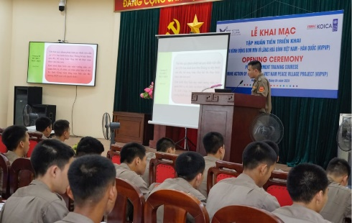 | 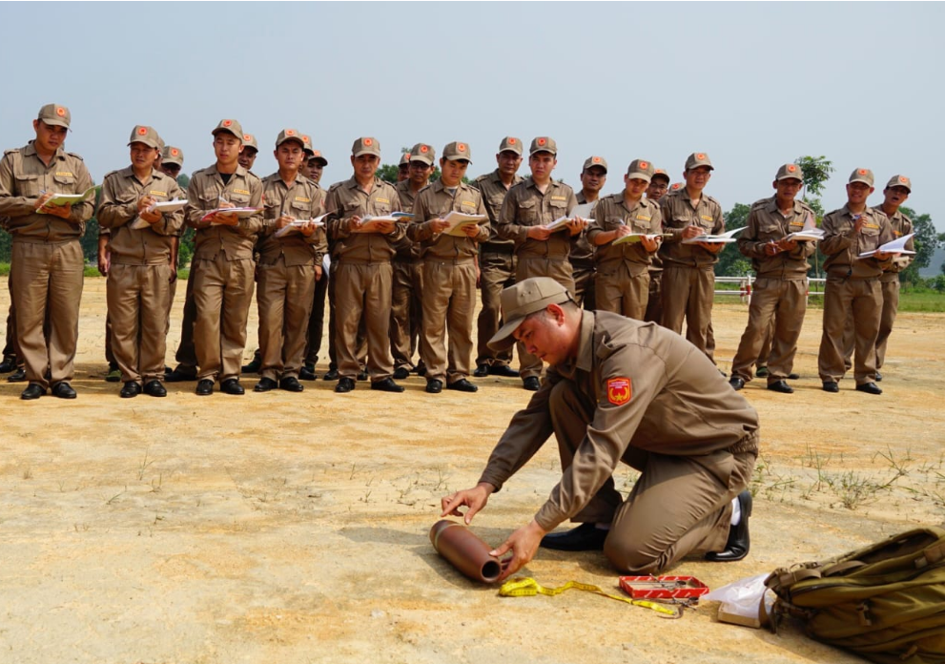 | 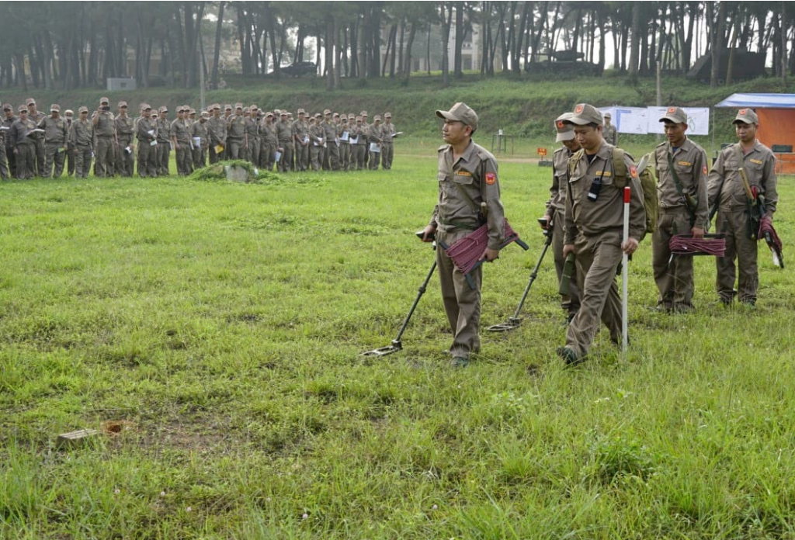
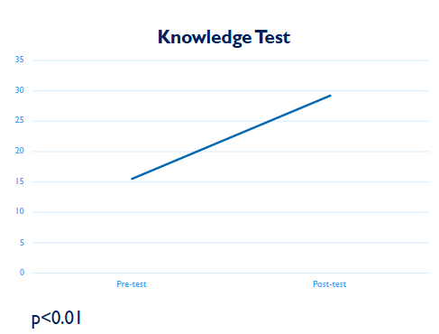 | 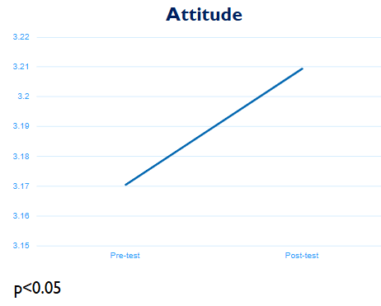 | 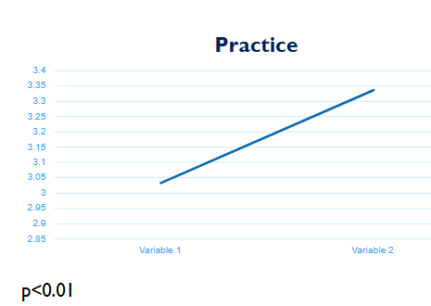
Photo 1 Participants attended the session on EO identification and technical survey simulation (above); Participants’ improvement in knowledge, attitude and practice on survey and clearance following the pre-deployment training (below)

Survey and Clearance Data
- Across the three provinces, the planned activities for 2024 have achieved an overall completion rate of 97.73% for technical survey, with 6,321ha out of 6,321 and 99.5% for clearance, with 1,375.5ha out of 1,394ha respectively, despite demining operations being launched only in late May.
- EO detection revealed significant findings. A total of 26,701 EO items were identified, with the highest number detected in Quang Ngai (21,606 items), followed by Binh Dinh (1,135 items) and Thua Thien Hue (1,977 items). Clearance operations played a critical role, contributing to 80% of EO findings, highlighting their importance in ensuring safety and land usability.
- Land release activities resulted in a total of 4,271.7 ha being reduced by technical survey and clearance. Released lands were handed over to communities, ensuring safe access and enabling productive use.

Table 1 Technical Survey Result in 2024
Province | Plan in 2024 | Implemented | Remaining | % completed
Thua Thien Hue | 1,386 | 1,353 | 33 | 97.62%
Quang Ngai | 2,772 | 2,697 | 75 | 97.29%
Binh Dinh | 2,310 | 2,271 | 39 | 98.31%
Total | 6,468 | 6,321 | 147 | 97.73%

Table 2 Clearance Result in 2024
Province | Plan in 2024 |  | Implemented |  | Remaining |  | % completed
Province | 0.3m | 3m | 0.3m | 3m | 0.3m | 3m | 0.3m | 3m
Thua Thien Hue | 297.4 | 14.0 | 334.7 | 14.0 | (37.3) | - | 113% | 100%
Quang Ngai | 593.3 | - | 569.7 | - | 23.5 | - | 96% | -
Binh Dinh | 486.8 | 2.5 | 455.4 | 2.5 | 31.4 | - | 94% | 100%
Total | 1,377.5 | 16.5 | 1,359.9 | 16.5 | 17.6 | - | 99% | 100%

Table 3 EO Detected in 2024
Province |  | Bombs | Cluster | Fuse | Artillery Shells 37-185mm | Mortar 60-120mm | Portable Rockets | Grenades (inc. M79) | Ammu-nitions | Othe EOs | Total
Bình Định | Technical Survey | 2 | 4 | 29 | 74 | 215 | 35 | 76 | 139 | - | 574
Bình Định | Clearance | - | 12 | 51 | 55 | 134 | 52 | 37 | 150 | 70 | 561
Quang Ngai | Technical Survey | - | 15 | 36 | 140 | 203 | - | 113 | 1,476 | - | 1983
Quang Ngai | Clearance | 1 | 12 | - | 231 | 197 | - | 2,607 | 18,557 | 1 | 21,606
Thừa Thiên Huế | Technical Survey | 1 | 107 | - | 143 | 104 | 43 | 45 | 302 | 3 | 748
Thừa Thiên Huế | Clearance | 1 | 81 | - | 154 | 104 | 32 | 35 | 807 | 15 | 1,229
Total |  | 5 | 231 | 116 | 797 | 957 | 162 | 2,913 | 21,431 | 89 | 26,701

Table 4 Land Release Result in 2024
 | Thua Thien Hue | Quang Ngai | Binh Dinh | Total
Reduced | 321.5 | 1,273.3 | 1,300.6 | 2,895.3
Cleared | 348.7 | 569.7 | 457.9 | 1,376.4
Total | 670.2 | 1,843.0 | 1,758.4 | 4,271.7

Quality Management (QM)
- VNMAC completed the QM plan for survey and clearance operations (Activity 2.3) in May and implemented QM activities for demining teams across three provinces. QA results were reported to UNDP monthly, with no major or critical non-conformities identified. Joint QM site inspections by VNMAC and UNDP were conducted in September and December as planned. VNMAC addressed findings and recommendations from UNDP’s QA reports in a timely manner.
Table 5 QA/QC Inspection for Technical Survey in 2024
Province | QA |  |  |  |  |  |  | QC
Province | Inspection |  |  | Non-compliance |  |  | Suspended operation | No. of Inspection | Area inspected (m2) | No. of QC failed
Province | Planned | Fulfilled | % | Minor (%) | Major (%) | Critical (%)
TT Hue | 98 | 98 | 100% | 34 | - | - | - | 98 | 88,644 | 26
Quang Ngai | 86 | 86 | 100% | 13 | - | - | - | 84 | 73,317 | 13
Binh Dinh | 122 | 122 | 100% | 21 | - | - | - | 130 | 104,861 | 16
Total | 306 | 306 | 100% | 68 | - | - | - | 312 | 266,823 | 55

Table 6 QA/QC Inspection for Clearance in 2024
Province | QA |  |  |  |  |  |  | QC
Province | Inspection |  |  | Non-compliance |  |  | Suspended operation | No. of Inspection | Area inspected (m2) | No. of QC failed
Province | Planned | Fulfilled | % | Minor (%) | Major (%) | Critical (%)
TT Hue | 84 | 84 | 100% | 22 | - | - | - | 100 | 63,575 | 22
Quang Ngai | 113 | 113 | 100% | 16 | - | - | - | 116 | 70,058 | 15
Binh Dinh | 143 | 143 | 100% | 25 | - | - | - | 147 | 79,156 | 25
Total | 340 | 340 | 100% | 63 | - | - | - | 363 | 212,789 | 62

c) Information Management (IM)
IM Training
- From August 26–30 in Quy Nhon, Binh Dinh, and September 16–20 in A Luoi, the IM Unit at VNMAC, with support from UNDP, conducted two training sessions on IM.

- A total of 108 participants, primarily team leaders and IM officers, attended the sessions. Pre- and post-training surveys indicated significant improvements in participants’ knowledge and technical capacities related to IM. The training also had a moderate impact on attitudes and practices, enhancing participants' perceptions, values, proficiency, and motivation regarding IM.

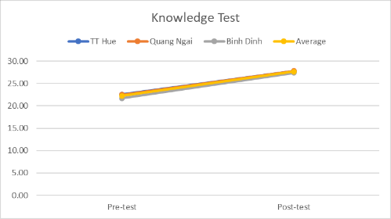 | 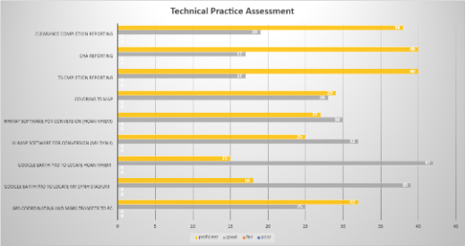 | 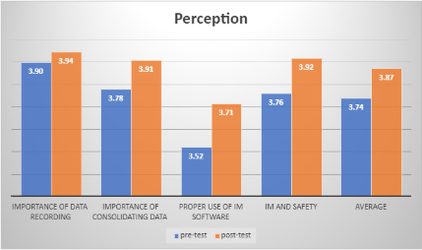
Knowledge Test | Technical Capacity Assessment | Attitude Survey

KPI Workshop
- On November 19, VNMAC and UNDP co-hosted a KPI workshop on mine action, with participation from QTMAC and mine action operators, including MAG, NPA, QTMAC and PeaceTrees Vietnam. The workshop focused on defining and implementing a standardized set of KPIs to enhance VNMAC's management of the KVPVP. Following the workshop, VNMAC committed to developing and applying these KPIs to the national mine action program, including for KVPVP.

Output 1.2: Support for Survivors and Persons with Disabilities (PWDs)
d) EORE
Consultations on EORE Plan
- On September 23, September 30, and October 7, 2024, VNMAC, with technical support from UNDP, organized three consultations on the EORE plan. These sessions involved 112 participants (80 male, 32 female) representing the Department of Education and Training (DOET), PMC, DOLISA, Youth Union, Women’s Union, and district agencies from Binh Dinh, Quang Ngai, and A Luoi district.
- Discussions focused on identifying effective EORE activities, drawing on baseline surveys and global and regional best practices. Following these consultations, EORE implementation plans for each province were finalized, establishing a strong foundation for coordinated execution by VNMAC and UNDP.
EORE Training for Local Communicators
- From September to October 2024, VNMAC conducted seven EORE training sessions for 329 local communicators and collaborators. Participants were selected from youth unions, women’s unions, and district and commune military personnel across 58 communes in 12 districts of Binh Dinh, Quang Ngai, and A Luoi. The training provided basic EORE knowledge and communication skills. Pre- and post-training evaluations showed notable improvements in participants’ knowledge, attitudes, and practices related to EORE.
Community Outreach and Activities
- On November 22, 2024, a month-long drawing contest was launched in 24 primary and secondary schools in A Luoi. The contest engaged 6,961 participants, including 3,346 boys and 3,542 girls, along with their family members, and awarded 78 outstanding entries. Throughout November, EORE safety posters were displayed at these schools, delivering important messages on explosive ordnance safety to students and their parents.
- From September to October 2024, trained EORE communicators conducted community events in five communes and two schools across Tay Son district, An Lao town, and Hoai An district in Binh Dinh. These events reached 859 community members, including 165 women, 565 men, 78 boys, and 77 girls. Participants engaged in interactive activities such as video clips, quiz games, and edu-entertainment plays to promote EORE awareness.

e) Victim Assistance
Training for Social Workers
- In October and November 2024, with technical assistance from UNDP, the Department of Social Assistance under the MOLISA organized nine training courses in Binh Dinh, Quang Ngai, and Thua Thien Hue provinces.
- A total of 521 social workers and collaborators (204 men and 317 women) participated, enhancing their knowledge and skills in providing social assistance for PWD and EO survivors.
Data Collection and Targeted Interventions
- After completing the training, communal and district social workers initiated the collection and verification of data on PWD and EO survivors. This data will be used to identify their specific needs and guide the development of focused and targeted interventions to support EO survivors in the coming years.

Outcome 2. Sustainable Rural Development
Output 2.1: Climate-smart and Resilient Agriculture for People in Target Areas
a) A Luoi- TT Hue
- Under Output 2.1, the project management unit (PMU) in A Luoi district implemented initiatives to help farmers adopt and scale up climate-resilient crop systems and practices. These efforts included improving farmers' access to microcredit, markets, and post-harvest opportunities, ultimately increasing their income through participation in value chains. As part of this initiative, 20 hectares were allocated for implementing the "3 decreases, 3 increases" technique in rice production, benefiting 197 farmers. Farmer Field School (FFS) trainings were conducted to enhance production techniques.
- A governance and operational training course for cooperatives and collaborative groups was also organized, benefiting 30 participants, including members of these groups.
b) Quang Ngai
- Under Output 2.1, activities aimed to support farmers by improving access to microcredit, markets, and post-harvest systems, as well as co-developing and operating localized agro-climate advisories. Training sessions were conducted for 35 farmers, focusing on market access, microcredit, and business planning for cooperatives and their members. Additionally, three training courses were organized for 86 farmers and 24 district- and commune-level officials, providing guidance on utilizing timely and reliable climate/weather information and enhancing crop production techniques.
c) Binh Dinh
- Under Output 2.1, the PMU carried out activities to assist farmers in scaling up climate-resilient crop systems and practices. During the 2023–2024 production period, peanut and rice production models were developed, each covering 3 hectares and benefiting 34 and 30 households, respectively. For the 2024–2025 production period, contracts were signed with Agriculture Service Centres in three project districts to implement models for rice, peanut, and irrigation systems for coconut production.

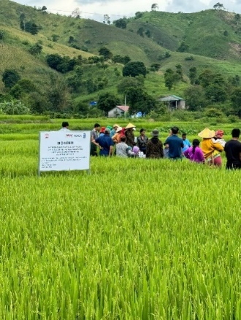 | 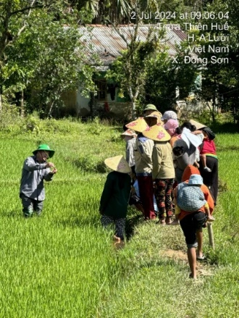
Photo 2 FFS training on 3G3T for the Summer-Autumn 2024 in A Luoi, Thua Thien – Hue

Output 2.2: Increased Resilience through CRHs and CHSs

In overall, the progress of CRH’s construction is positive and will meet target in 2025 as shown below in the table. It is reported by beneficiaries that they feel much safer in the new houses in case of extreme weather. The following table provides an overview of completed Climate Resilient Houses (CRHs) in 3 provinces:
 | 2023 | 2024 | Plan for 2025
TT Hue | 0 | 135 | 25
Quang Ngai | 21 | 74 | 25
Binh Dinh | 2 | 118 | 0

Regarding Commune Health Stations (CHSs), 06 CHSs have been completed in Binh Dinh (01 in 2023 and 05 in 2024). Thua Thien Hue and Quang Ngai’s PMU are in final stage of preparation and mobilizing contractors to commence CHSs in the beginning of 2025 as shown below in the table.
 | 2023 | 2024 | Plan for 2025
TT Hue | 0 | 0 | 10
Quang Ngai | 0 | 0 | 11
Binh Dinh | 1 | 5 | 14

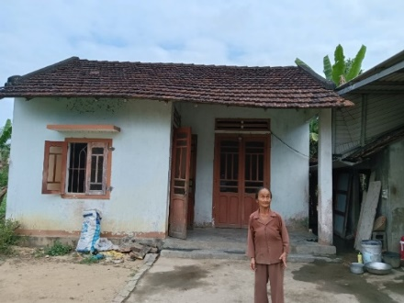 | 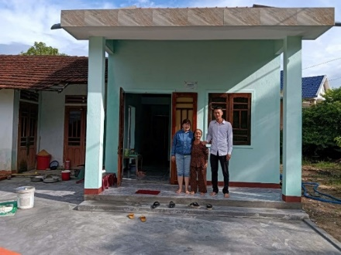
Photo 3 The project supported a CRH for a female-headed household (before and after)
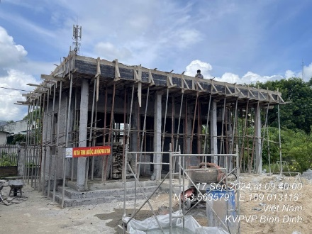 | 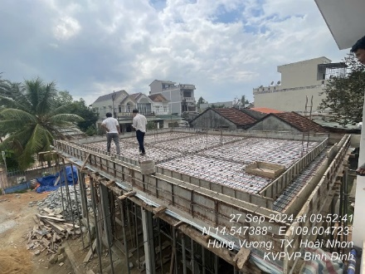
Photo 4 Construction of the CHSs in Binh Dinh in September 2024

National and International Coordination
a) Facilitation of VNMAC Participation at International Events to Strengthen and Enhance Vietnam’s Role in Mine Action
UNDP supported VNMAC in participating in two significant events: The (NDM-UN27 held in Geneva from April 29 to May 1, and the ASEAN Regional Mine Action Centre (ARMAC) Workshop on Victim Assistance in Bangkok from April 28 to 30.
At NDM-UN27, UNDP facilitated a series of bilateral meetings between VNMAC and key stakeholders, including the ROK Ministry of Defence and Army Engineers, to promote knowledge exchange. Additional meetings were held with UNDP headquarters to discuss technical cooperation and with GICHD to integrate mine action into SDG assessments.
During the ARMAC Workshop, UNDP introduced Vietnam’s Theory of Change on Victim Assistance and supported VNMAC in networking with regional stakeholders from ASEAN Member States.
In December, UNDP’s EORE and VA component manager joined VNMAC representatives at an ARMAC workshop in Phnom Penh (December 17–19). Together, they provided inputs on the development of regional EO and VA guidelines.
Additionally, at the 4th ROK Mine Action Seminar held on October 29, UNDP’s Chief Technical Advisor (CTA) delivered a presentation highlighting Vietnam’s mine action progress and UNDP’s initiatives in this area. The CTA also conducted a special lecture for KOICA managerial staff on the theory and practice of the Humanitarian-Development-Peace (HDP) Nexus, positioning mine action as a model for HDP integration. The seminar provided a platform for networking with ROK think tanks and academia to explore technical innovations for the KVPVP.

b) Coordination with the Mine Action Community in Vietnam through MAWG
In 2024, the MAWG convened four quarterly meetings on April 11, June 14, October 11, and November 18. These meetings brought together representatives from over 20 organizations, including VNMAC, mine action entities, regional and international organizations, donors, and local authorities. The meetings were co-chaired by Peace Tree Vietnam and UNDP.
To ensure broad participation from provinces and localities, the meetings were conducted in a hybrid format, combining in-person and online modalities. These gatherings served as a crucial platform for information exchange among stakeholders addressing the legacies of war in Vietnam, the region, and beyond. A key achievement in 2024 was the consistent and full engagement of VNMAC, reflecting the Vietnamese Government’s strong commitment to advancing mine action initiatives.
The discussions saw active participation from international mine action organizations and donors, including the Implementation Support Unit (ISU) of the Anti-Personnel Mine Ban Convention (APMBC), the ARMAC, the Cambodia Mine Action and Victim Assistance Authority (CMAA), as well as representatives from the embassies of the United States and Ireland.
Key topics addressed during the 2024 MAWG meetings included:
- Development of the Ordinance on Mine Action: Updates on progress and the incorporation of collaborative inputs.
- Capacity Development and IM: VNMAC’s humanitarian demining training capacities demonstrated significant progress compared to 2018, supported by UNDP’s technical expertise.
- Relaunch of the MAPG: Updates on its activities, objectives, and strategic direction.
- National Strategy for EORE: A comprehensive strategy was developed by VNMAC with support from Catholic Relief Services (CRS).
During the fourth-quarter meeting on November 18, MAWG organized a special session previewing the 5th Review Conference of the APMBC, held in Phnom Penh from November 25–29. The session included updates from the ISU and CMAA on key agenda items and the strategic direction of the Phnom Penh Action Plan, building on the foundations laid by the Oslo Action Plan.

c) Assessment of KVPVP’s Alignment and Contribution to SDGs
The strong connection between Mine Action and the 2030 Agenda for Sustainable Development was underscored in a 2017 collaboration between UNDP and (GICHD in Cambodia. Similarly, KOICA Future Community Development Program in the Mekong region, launched in 2020, highlighted the strategic importance of mine action in fostering sustainable rural development. Building on these foundations, the KVPVP project has been designed as an integrated initiative, aligning Survey and Clearance activities with Rural Development efforts to maximize impact.
Following preliminary discussions at NDM-27 in Geneva, UNDP convened a follow-up meeting with VNMAC and GICHD to plan an assessment of KVPVP’s contribution to the SDGs. This assessment aims to measure the project’s tangible impact on the SDGs and provide actionable recommendations for integrating mine action with development efforts to achieve broader sustainable development objectives in Viet Nam. In preparation for the planned activities in 2025, UNDP and VNMAC have provided baseline data through GICHD’s questionnaire, laying the groundwork for the collaborative assessment.

Operations
a) Human Resources
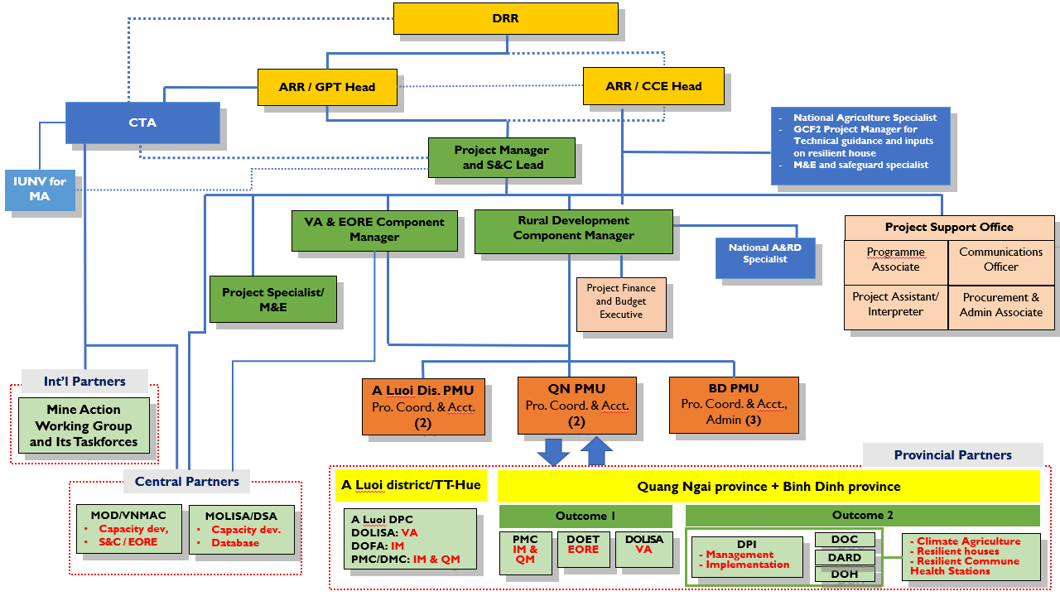
Infographic: Project Organigram
Project Manager (PM)
- On April 1, Mr. Doan Huu Minh officially departed from the team, creating a leadership gap in the project management team. To address this, Ms. Nguyen Thanh Van, formerly the Component Manager for VA and EORE under the KVMAP project, stepped in as Officer-in-Charge (OIC) for the Project Manager position on the same day.
- On September 10, Ms. Nguyen Thu Ha officially assumed the role of Project Manager, enhancing the team’s leadership and technical capacity. Her focus includes survey and clearance (S&C), IM, and overall coordination and management between the two project outcomes.
Mine Action Specialist (IUNV)
- The recruitment process concluded successfully with Mr. Hyosub Kim, a Korean national, joining the Hanoi office on October 8 as a Mine Action Specialist.
Procurement and Administrative Associate (NPSA6)
- The Procurement Consultant (IC) commenced their assignment on April 22, 2024, with a focus on expediting procurement processes, completing their tenure by the end of October 2024.
- To sustain support for procurement operations and administrative tasks, the recruitment process for a Procurement and Administrative Associate (NPSA6) is currently underway. This new role is expected to provide crucial operational and administrative support, ensuring the seamless continuation of procurement activities and overall administrative functions.
Mine Action Analyst (IPSA9)
- The recruitment process for the Project Analyst for Mine Action, responsible for M&E, communication, and reporting as well for enhancing gender mainstreaming across all project components is currently underway. Previously, a Programme Specialist under an Individual Consultant (IC) contract handled these tasks until the contract ended in early November 2024.
- The selection process for the International Project Analyst is now in its final stages. This role is expected to enhance the team’s analytical capacity in mine action, further advancing the project’s objectives.
National Agriculture Specialist
- Initial recruitment attempts for the International Agriculture Specialist were unsuccessful. Following feedback from the field and consultations with KOICA, the position was converted to a national post to improve cost-effectiveness and strengthen local engagement. Recruitment for the national position is currently underway, with updates to follow as discussions with KOICA progress.

b) Procurement
Completed Procurement
- UNDP has successfully procured and delivered several items outlined in the Project Document to VNMAC’s JPMU and three provincial site commands. The delivered items include:
  - A 16-seater Hyundai minibus
  - 26 GPSMAP 65S devices
  - 50 Type-B first aid kit bags
- All items were tested for quality, stamped with project stickers for inventory and asset management, and officially handed over to VNMAC. Additionally, most equipment from the first batch, approved during the JPCC meeting on June 27, 2024, was delivered to VNMAC by December 2024 (see accompanying table for details).
Incomplete and Planned Procurement
- First Batch Delays: Two critical items from the first batch—127 VMH3CS mine detectors and 33 Vallon VX1 bomb detectors—were ordered and ready for shipment by October 2024. However, delays in obtaining an official letter from the Ministry of Defense of Vietnam to facilitate the tax exemption process prevented their shipment. As of December 31, 2024, these items remain undelivered.
- Second Batch Procurement: In December 2024, at the request of the VNMAC PMU, UNDP initiated the procurement process for the second batch of equipment. Delivery is expected in the first quarter of 2025 (details are provided in the accompanying table).
Table 8 First Batch of Equipment in July 2024
No. | Item | Quantity | Status
1 | Logitech Group online meeting equipment | 01 | Delivered
2 | Professional Canon XA 75 Camcorder | 01 | Delivered
3 | HP LaserJet Enterprise Flow MFP M880z multi-function colour printer | 02 | Delivered
4 | Samsung Galaxy Tablet | 12 | Delivered
5 | Motorola P6620i VHF TUA walkie-talkie | 38 | Delivered
6 | HP LaserJet Pro 4003dn black and white printer | 50 | Delivered
7 | L1 HP EliteBook 840 G10 laptop | 50 | Delivered
8 | Office Home and Business Software package | 51 | Delivered
9 | Fuji Xerox Apeosport 5570 black and white photocopier | 02 | Delivered
10 | VMH3CS mine detectors | 127 | Pending
11 | Vallon VX1 bomb detector | 33 | Pending
Table 9 Second Batch of Equipment in 2025
No. | Item | Quantity | Expected Delivery time
1 | ArcGIS Enterprise User Type software license | 03 | Mid-Jan 2025
2 | HP ZBook Power 16-inch G11 | 05 | End of Feb 2025
3 | 05 LG 27QN600 Monitor - 27 inch | 05 | End of Feb 2025
4 | Ugreen 40744 high-quality HDMI to VGA&HDMI converter cable | 05 | End of Feb 2025
5 | AKKO 3108 RF Black on White Mechanical Keyboard (2.4Ghz / AKKO sw v3) | 05 | End of Feb 2025
6 | Logitech G102 LIGHTSYNC RGB | 05 | End of Feb 2025
7 | HP LaserJet Pro MFP M227SDN G3Q74A Black and White Laser Printer | 03 | End of Feb 2025
8 | HP LaserJet Pro CP5225DN (CE712A) A3 Colour Laser Printer | 04 | End of Feb 2025
9 | Epson i3200 UV DTF Taimes T600 3 ink head printer | 01 | End of Feb 2025
10 | L1 - HP Elitebook 840 G10 or equivalent laptop | 03 | End of Feb 2025
11 | HP Laser Jet Pro 4003dn –Printer | 03 | End of Feb 2025

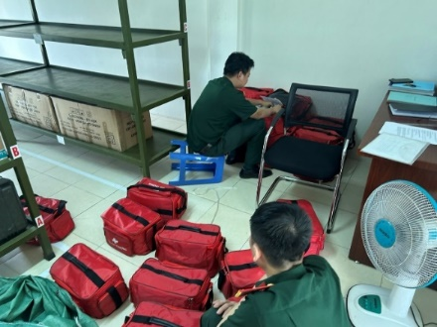 | 
First-aid kits | Hyundai minibus
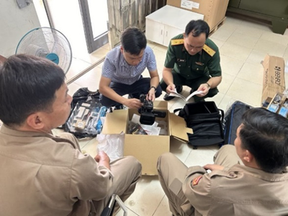 | 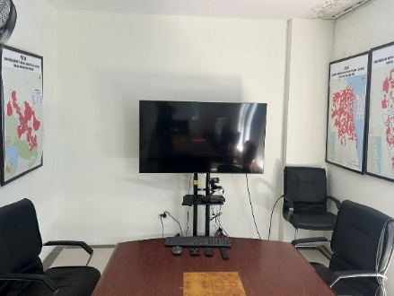
Online Meeting System at VNMAC 1 | Online Meeting System at VNMAC 2
Photo 5 KVPVP Procurements in 2024

c) Communications
- KVPVP has gained visibility through media coverage, social media updates, beneficiary stories, educational materials, and a planned project website launch. These efforts highlight milestones, raise awareness, and engage communities. Details are explained below and available in the annexes.
- The launch ceremony of the project in April received extensive coverage in national media, including newspapers and broadcasting channels. Additionally, all partner organizations actively shared news about the project on their social media platforms. (Refer to media clippings in Annex 4.2.1)
- Updates on the project's progress were regularly featured on the social media channels of UNDP Viet Nam and VNMAC. These updates highlighted milestones such as the successful handling of EO, EORE activities, training sessions, and regular meetings. (Links in Annex 4.2.2)
- On the International Day of Mine Awareness and Assistance in Mine Action 2024, Viet Nam contributed to the global message video coordinated by UNMAS. A series of quote cards were also developed to share the stories of beneficiaries and raise awareness about mine action. (Link in Annex 4.2.3)
- A feature story about KVPVP beneficiaries in Binh Dinh was published on UNDP’s website and story platform. (Link in Annex 4.2.4)
- A Vietnamese-language project poster was designed to be displayed at local Project Management Units (PMUs), offering clear and visually appealing information for local communities to better understand the project. (Link in Annex 4.2.5)
- As part of the EORE campaign, an educational poster about the risks of EO accidents was distributed to 24 schools in A Luoi District, Thua Thien Hue.
- A mock-up for the KVPVP website was completed, with plans to launch the full site in 2025. (Link in Annex 4.2.6)

Challenges and Counterplans
Challenges | Counterplans
Outcome 1
Overlap in Capacity Assessment Tools:  UNDP established a capacity development framework based on the capacity assessment completed during KVMAP (2018–2022). However, partners like NPA have developed separate assessment tools to evaluate VNMAC’s capacity, leading to potential overlaps and inefficiencies. | To avoid duplication, coordination is crucial—either to develop a unified assessment tool or clearly define roles for harmonized evaluations. Coordination discussions between UNDP and NPA will commence in 2025. Additionally, UNDP’s HQ Mine Action team will engage with NPA HQ to develop a common regional approach across countries, including Vietnam, to mitigate these overlaps.
Coordination Challenges in EORE:  The appointment of a new EORE manager at VNMAC in late 2024 caused initial coordination challenges with provincial partners, resulting in fewer EORE events in Binh Dinh. | UNDP closely followed up with the new EORE focal point of VNMAC and supported him with the project implementation. Any challenges and difficulties encountered during that transitional period were timely shared with the UNDP component manager and the measures discussed and agreed.
Technical and Administrative Challenges in Registry Software:  The software of registry and IM of PWD and EO survivors developed and used during 2018 and 2022 was posing technical errors for the communal and districts in the new project sites due to the version being out-of-date; meanwhile the agency administering the software is under restructuring, merging into another government agency. This is causing a challenge in completing the database of PWD and UXO survivors as planned. | UNDP closely worked with the DSA and the software developer to inform them of technical errors and asked for support to fix them.  As an interim measure, UNDP also decided to prioritize data collection on the needs of EO survivors, using the paper-based approach, and consolidate it so as to inform the development of the interventions to support the EO survivors in the 3 provinces. The tentative plan for upgrading the software will be revisited between UNDP and DSA (or a newly designated entity) once the new government structure of social assistance for EO survivors and PWDs is stabilized.
New ODA Regulations:  New ODA regulations prevented DSA from establishing its own project management unit, causing delays due to multi-layered management. | UNDP worked with DSA to create a detailed implementation plan with budget allocations and ensured VNMAC’s involvement to streamline operations.
New VNMAC Financial Focal Points:  VNMAC’s new financial focal points faced challenges managing ODA projects and ensuring compliance with UNDP’s financial rules | UNDP provided guidance through updated handbooks, financial training, and quarterly reporting support to improve compliance.
Loose Coordination:  Coordination gaps between VNMAC and PPMUs affected the logical sequencing between mine action and rural development activities | UNDP introduced a coordination guideline, convened meetings with PPMU stakeholders, and strengthened collaboration to align project components effectively.
Shortened Project Implementation period:  MoD’s delayed project approval reduced the project timeline from five years (2022–2026) to three years (2024–2026), creating funding challenges. | UNDP has already initiated a series of coordination meetings with KOICA and VNMAC.  A no-cost extension will be considered to address the donor’s annual budget disbursement requirements and comply with ODA funding regulations.
Increased Allowance:  The Prime Minister’s decision 16/2024/QĐ-TTg to increase daily allowances for national deminers by 200% effective from January 2025 has impacted survey and clearance budgets and operations. | In the tripartite meeting between UNDP, KOICA and VNMAC on 5th December, it was agreed that VNMAC will send a note to file officially clarifying the rationale of the Government's Decision 16/2024/QĐ-TTg and propose the optimal solution between the budget and the area of clearance according to two options: (1) propose the Government of Korea to increase the budget, keeping the targeted area of S&C as planned by MoD or (2) develop a plan according to the budget allocated as informed by KOICA, and accordingly reducing the target S&C areas.
Outcome 2
Impact of the Law on Procurement 2023:  There are some updates on the legal framework on procurement, especially the issuance of Law on Procurement 2023. This causes some delays in procurement packages for agricultural activities as project partners need time to understand and comply with new regulations. | UNDP closely followed up with project partners to provide technical advice and support for necessary revisions of procurement plans.
Strict Compliance with Public Investment Regulations:  Since all three sub-projects in A Luoi district/Hue city, Quang Ngai and Binh Dinh provinces are public investment projects, implementation of all project activities and disbursement must strictly follow regulations of Government of Viet Nam causing delays, especially in the construction of climate resilient commune health stations. | UNDP closely worked with all three PPMUs to provide timely support in all steps and procedures to speed up the process as quickly as possible.

Lessons Learned
- Evidence-Based Measurement of Trainings:
The evidence-based measurement of training activities, supported by UNDP, has significantly enhanced VNMAC’s capacity for knowledge management and skills development in humanitarian demining. This approach has facilitated the design of need-based courses, fostered interactive facilitation, and ensured effective course management.
- Strong Local Coordination and Stakeholder Engagement:
Close coordination with provincial implementation partners and the strong commitment of provincial authorities to EORE have been pivotal in ensuring the smooth implementation of project activities. Social organizations, particularly the Youth Union and Women’s Union, have played a crucial role in delivering EORE activities and integrating EORE content into regular communication channels and community meetings.
- Clear Guidance for Multi-Stakeholder Projects:
Providing clear guidance on coordination among project implementing partners is essential for multi-stakeholder projects. Such guidance ensures that project components are implemented in a well-coordinated manner, complementing each other to achieve optimal results. This is particularly important for a project that seeks to demonstrate the nexus between mine action and development.
- Financial Monitoring and Risk Mitigation:
Close monitoring of accounting and financial disbursement activities conducted by project partners is essential. This oversight helps identify potential risks of non-compliance with UNDP financial regulations at an early stage, thereby preventing delays or complications in the settlement of project expenditures.

Achievement(s) in Cross-Cutting Issues

Gender mainstreaming
- As the former chair, UNDP encouraged a gender focal point at VNMAC actively participate in the meetings of the Taskforce on Gender, Diversity, and Inclusion under the MAWG. These engagements provided updates on the progress of the National Action Plan on Women, Peace, and Security and highlighted its relevance to the mine action sector. UNDP plans to assume the chair of the Taskforce in 2025 to lead gender mainstreaming in mine action in collaboration with taskforce members.
- UNDP successfully secured a grant from Canada to enhance awareness and understanding within VNMAC and mine action operators regarding gender issues and the critical contributions of women to mine action. This initiative aims to promote women’s inclusion and equality, accelerating gender mainstreaming in mine action activities. Planned activities for 2025 include gender analysis and recommendations, stakeholder workshops, advocacy initiatives, and a photo exhibition. These activities will be implemented in a synergistic manner with KVPVP.
- UNDP prioritized women’s participation in EORE and VA activities throughout the project’s planning and implementation. The terms of reference for these activities explicitly outlined selection criteria to ensure women’s inclusion. Additionally, sex-disaggregated data was collected from EORE and VA workshops, training sessions, and events. These efforts achieved the target of having more than 30% of participants in training, workshops, and events be women.

Social and Environment Management
- The mine action activities of KVPVP are implemented in accordance with the Vietnam National Mine Action Standards (TCVN VNMAS), which are adapted from the International Mine Action Standards (IMAS). These standards promote the standardization of safe and effective mine action to minimize the social, economic, and environmental impact of landmines and UXO.
- The construction of CRHs and CHSs adheres to both national and international standards, as well as best industry practices.
- The Social and Environmental Screening Procedure (SESP) report has been developed and revised. In collaboration with Social and Environmental Standards (SES) experts from UNDP’s Bangkok Regional Hub and the Global team, UNDP is finalizing the recruitment of a national consultant to develop a comprehensive Environmental and Social Management Plan for the project. The plan will address SES-related issues and ensure compliance with UNDP and international standards for environmental and social safeguards

Communication and Partnership with KOICA
In 2024, UNDP held multiple meetings with KOICA to ensure effective collaboration and successful implementation of the KVPVP. These included monitoring meetings, regular discussions, and steering committee sessions, which focused on project planning, coordination between Outcomes 1 and 2, financial policies, and field inspections. High-level representatives from UNDP, KOICA, and VNMAC participated, promoting close coordination and addressing key challenges to achieve project objectives. The description of the events is shown below:
- 17 April 2024: A joint meeting between the UNDP ARR, KOICA Country Deputy Director, and VNMAC General Deputy Director discussed the KVPVP implementation plan following the Prime Minister's approval in February and the MoD’s approval in March 2024. The meeting also covered preparations for pre-deployment training and the project launch.
- 23 May 2024: UNDP Resident Representative (RR), KOICA Country Director, Vice Minister of Defence, VNMAC Director General, and other senior leaders participated in the KVPVP project launch in Tay Son District, Binh Dinh Province. Before the launch, they joined a handover ceremony for a climate-resilient communal health station in Phuoc Thanh, Tuy Phuoc District, and visited a climate-resilient house provided to a poor woman-headed household.
- 21 June 2024: UNDP ARR and KOICA Country Deputy Director discussed preparations for the JPCC meeting, including sequencing and coherence between Outcome 1 and Outcome 2 of the project and coordination between VNMAC and the three PPMUs.
- 27 June 2024: UNDP RR, KOICA Country Director, VNMAC Director General, representatives from DSA/MOLISA, and provincial representatives from Binh Dinh, A Luoi, and Quang Ngai discussed and agreed on the multi-year work plan, the 2024 work plan, communication plan, and draft coordination handbook.
- 5 September 2024: UNDP ARR and the new KOICA Country Deputy Director discussed project progress and pending issues, including VNMAC’s participation in the ROK mine action seminar, international engagement activities for 2025, review and revision of fund transfer milestones, and other project-related concerns.
- 17–18 September 2024: UNDP ARR, KOICA Country Deputy Director, VNMAC Deputy Director General, and the Director of PPMU in A Luoi discussed strengthening coordination and sequencing between Outcome 1 and Outcome 2. The team also inspected progress and performance of the demining teams at two selected sites in A Luoi District.
- 5 December 2024: UNDP ARR, KOICA Country Director, and VNMAC Deputy Director General discussed financial policies, including the ceiling fund transfer amount for the ODA project, increased allowances for demining teams under new government regulations, and the possibility of a no-cost project extension.
Additionally, UNDP submitted regular reports to KOICA, providing detailed updates on project progress and future plans on a monthly, quarterly, bi-annual, and annual basis. All reports were delivered in the month following their respective reporting periods, ensuring timely communication and alignment.
Table 10 UNDP's Reports to KOICA
Name | Description | No. of Items | Reporting Period
KVPVP Monthly Achievements and Plan | Updates and plans of project activities in a simple format | 7 | February, April, May, July, August, October, November
KVPVP Quarterly Report | Summary and evaluation of activities over three months | 2 | January–March,  July–September
KVPVP Bi-annual Report | Summary of progress and challenges | 1 | January–June
KVPVP Annual Report | Comprehensive report of the year’s activities | 1 | January–December

Risk Management
Risks | Mitigations
Funding Shortfall in 2025:  UNDP initially sent VNMAC a budget plan based on USD 4 million (agreed during a three-party meeting), with USD 2.5 million allocated for technical survey and clearance (TS/CL) activities (including UNDP’s 8% GMS). VNMAC indicated during a PMU meeting that this amount would only sustain operations until June 2025. After KOICA’s letter on December 23 confirmed an approved budget of USD 2.9 million, with an additional USD 1.1 million pending approval, UNDP revised and submitted a new budget plan. However, VNMAC stated this amount would only last until April 2025. | In discussions with VNMAC, UNDP proposed that VNMAC either delay the deployment or reduce the number of TS/CL teams to extend operations throughout the year. This adjustment would ensure that TS/CL activities under Outcome 1 are aligned with Outcome 2's rural development activities, avoiding gaps caused by premature withdrawal and redeployment of teams.
Extended delays in Identifying Rural Development Areas:  The three provinces have yet to identify areas for rural development activities, which is essential for aligning Outcome 1 and Outcome 2 activities. Government restructuring at provincial levels has further delayed the process due to the merging of key departments (DOLISA, DPI, DARD) involved in KVPVP. | UNDP sent letters to the three provinces urging them to identify rural development areas by the end of Q1/2025. This timeline is critical to prevent the risk of TS/CL teams withdrawing before the approval of the rural development plan.
Premature Withdrawal of TS/CL Teams:  If rural development areas are not identified in a timely manner, VNMAC’s TS/CL teams may withdraw before the rural development plan is finalized. This would disrupt the synchronization of TS/CL and rural development activities. | UNDP has consistently advised VNMAC and proposed that the MoD reduce the number of deployed TS/CL teams or postpone deployment by 1–2 quarters. This would allow synchronization of activities, ensuring that cleared land is immediately available for rural development interventions.
Government’s Restructure:  The government decision to restructure the cabinet and its Ministries launched in late 2024, including MOLISA affects the progress and the implementation of the VA activities. As a result, some of the activities under VA led by DSA/MOLISA such as upgrading the software for registry and IM of PWD and UXO survivors, integration of VA data into the national database of mine action was temporarily delayed and under review for reprogramming. | UNDP proactively discussed with DSA focal points to work on the project proposal once the administrative structure is stabilized. A meeting with Ministry of Health leadership that will be in charge of PWD and EO survivors and DSA post-restructure will be arranged to establish a strong partnership for project component implementation.

Financial Management
Due to delays in project implementation, the payment schedule for KOICA funds to UNDP, as outlined in the Grant Agreement (GA) dated March 17, 2022, requires amendment. This adjustment is necessary to align with the updated project timeline and ensure the availability of funds to support the approved multi-year workplans for VNMAC and the three project provinces. The detailed finance report will be shared with KOICA separately as UNDP is finalizing FY 2024 internally.

ANNUAL WORK PLAN FOR YEAR 2025

Based on the project objectives, priorities of the government partners, and annual workplan for 2025, the key expected results of 2025 will be as follows:
Outcome 1: Improved Human Security
1.1. Mine Action Authorities Have Strengthened Capacity:
- Strengthened Legal Framework for Mine Action: The Ordinance on Mine Action is advanced through consultative dialogues and the provision of key reference documents.
- Increased Global Engagement: Vietnam’s participation in regional and global mine action events is strengthened, enhancing its international visibility and role in the sector.
- Enhanced Coordination and Resource Mobilization: MAPG-related working group meetings are effectively facilitated, fostering stronger collaboration and knowledge exchange between domestic and international stakeholders to mobilize resources for mine action initiatives.
- Integration of Mine Action with SDGs: An assessment report evaluates the contribution of mine action efforts to the achievement of Sustainable Development Goals (SDGs), informing policy and program alignment.
- Improved Project Evaluation Mechanisms: A set of indicators is developed and applied to assess the effectiveness and impact of mine action projects, strengthening monitoring and evaluation processes.
- Strengthened IM Capacity: Field-based IM personnel receive advanced training, and field inspections enhance the accuracy of data collection and verification processes, improving reporting quality.
- Enhanced Risk Mapping and Disaster Preparedness: A study is conducted to integrate landmine/Explosive Ordnance (EO) risk maps with disaster and climate risk maps in three project provinces, enhancing preparedness and response measures.
- Improved Quality Management (QM) Systems: VNMAC’s E-QMS is reviewed and updated as necessary to ensure alignment with international best practices and operational efficiency.
- Strengthened Explosive Ordnance Risk Education (EORE) and Community Awareness: Approximately 20,000 education managers, teachers, and community members (including schoolchildren and farmers) improve their knowledge of EO safety, contributing to a reduction in EO-related accidents.
1.2. Contribute into Addressing Post-war Landmines/EO Contamination in Three Provinces in the Prioritized Areas for the Development of Peace Villages:
- Technical Survey Completion: A total of 2,751 hectares of land is surveyed, enabling the release of land without evidence of contamination and verifying areas suspected of containing explosive ordnance (EO).
- Clearance Achieved: 286 hectares of land are cleared to a depth of 0.3m, making it safe for use, while 67 hectares are cleared to a depth of 3m, specifically prepared for the construction of CRHs, CHSs, and rural development activities.
1.3. Victim Assistance:
- Improved Data Management: The software for registering and managing EO survivors and persons with disabilities (PWD) information is upgraded, ensuring better data accuracy and accessibility.
- Targeted Assistance Provided: Approximately 240 EO survivors receive tailored support based on verified needs, improving their access to essential services.
- Strengthened Social Assistance Capacity: The capacity of social workers and officers responsible for assisting PWDs and EO survivors is enhanced, equipping them with the necessary skills to provide more effective and comprehensive support.
Outcome 2: Sustainable Rural Development
2.1. Promote Climate-smart, Resilient Agriculture in Target Areas
- Expanded Agricultural Assistance: More than 6,000 beneficiaries receive technical and financial support, including agricultural instruments, fertilizers, and other essential inputs to improve productivity.
- Strengthened Agricultural Production and Market Access: Climate-vulnerable communities benefit from enhanced agricultural production support, improved access to markets, and agro-climate information.
2.2 Enhance resilience with flood- and storm-resistant houses and commune health stations
- Completed and Handed Over CRHs: A total of 400 CRHs are completed and handed over.
- Completed and Handed Over CHSs: A total of 30 CHSs are completed and handed over.

ANNEX

KVPVP Project Map
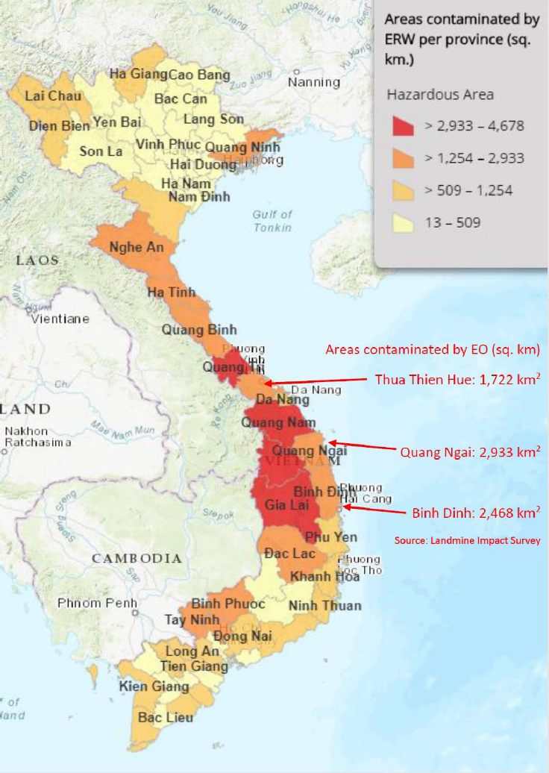

Communication
No. | Document Name | Link
1 | KVPVP Launch Media Clippings | - https://drive.google.com/file/d/16kH8m0VI27CNpMU0fjyOGWfRAdVG0cDy/view?usp=sharing
2 | Social Media Posts | Successful Handling of EOs:  - https://www.facebook.com/undpvietnam/posts/pfbid02Q3fkgMUGDUgvDfWnmN7BW9mXsJGjYHkNoUQ9P6k7hZpenSkXtKT5hBepAByVUkA4l  - https://x.com/UNDPVietNam/status/1851971598074679641  - https://x.com/UNDPVietNam/status/1825466529263366534  - https://www.facebook.com/vnmac.gov.vn/posts/pfbid02vsz473FnGLqCJLEHx91u8jYe4juyAsqVkNN5rTuBt6NhCKR98v4gUATaq9RN2Aiul  - https://www.facebook.com/vnmac.gov.vn/posts/pfbid0373HM9sSmb7BWD6jUDTNPr3aeXbfyETnVCsgg3fZbbzZUaZjfz76ZfZY8jXGNYnwMl  EORE Activities:  - https://www.facebook.com/vnmac.gov.vn/posts/pfbid02i6LbUirHi3pURbH79BKw1nGJbW9ZUtWhibbcPy5mAXgoE45wWSfU9A85htrTeqPZl  - https://www.facebook.com/vnmac.gov.vn/posts/pfbid031BXhFNTuRxQdW2EWHU2FiQifiNs4MLc1GQyYQ6UYFGfLDM7zW7Bwx4M7AFVazDCLl  - https://www.facebook.com/undpvietnam/posts/pfbid0x1Bd7FjPwArzwnaBfkrNdfNko4zBzrShgDApG1LxAhGdQbN1Tb1pBM5dG42uJsiAl  - https://x.com/UNDPVietNam/status/1871114243422245251  Handover of CRHs and CHCs:  - https://x.com/UNDPVietNam/status/1793929497684963346  - https://x.com/RamlaKhalidi/status/1793281032462229861  Pre-deployment Training:  - https://x.com/UNDPVietNam/status/1784881885421678672  JPCC Meeting:  - https://x.com/RamlaKhalidi/status/1806548773113635219
3 | International Day of Mine Awareness and Assistance in Mine Action 2024 | - https://www.undp.org/blog/landmines-kill-seconds-their-fallout-lasts-generations  - https://x.com/UNDPVietNam/status/1775755512942117172  - https://x.com/UNDPVietNam/status/1775696694648373621  - https://www.facebook.com/undpvietnam/posts/pfbid0281rVUqf65Q1MMrrZwXzaeVG3HrXpD1EroV8whhJ9ahJfyg1fCGqP95xLv4tc47Wyl
4 | A New Roof of Hope Story | - https://undpvietnam.exposure.co/a-new-roof-of-hope
5 | Project Posters | - https://drive.google.com/file/d/160l7H2Ey13-V3QuWnL-RNbmEKltm6tVG/view
6 | Mock-up Website | - https://kvpvp.my.canva.site/

Survey and Clearance includes both Technical and Non-Technical Survey methods
The project faced delays due to an extended review by Vietnamese authorities. Outcome 1 on mine action began in May 2024 after Ministry of Defence approval, while Outcome 2 on rural development started earlier in late 2023.
End of Report

